**Mental Health Wellbeing and Recovery Services**

Referral Form

**Provider Details for Referral Forms:-**

**Leicester City, Oadby, Wigston & Blaby**

[**Richmond.fellowshiplifelinks@nhs.net**](mailto:Richmond.fellowshiplifelinks@nhs.net) **Free Phone 0800 0234575 (SPOA)**

**4th Floor 60 Charles Street, Leicester. LE1 1FB**

**Charnwood, North West Leicestershire, Hinckley & Melton**

**[leicestershireandrutlandmhm@nhs.net](mailto:leicestershireandrutlandmhm@nhs.net) free phone 0300 3230 189 Single Point of Access**

**Swithland Suite The Crescent, 27 King Street, Leicester LE1 6RX**

**Harborough**

[Harborough.mindmatters@nhs.net](mailto:Harborough.mindmatters@nhs.net) **01858 411383**

**1st Floor Torch House, Torch Way, Market Harborough, Leicestershire LE16 9HL**

|  |  |
| --- | --- |
| **Full Name** |  |
| **Date of Birth** |  |
| **Current address** |  |
| **Contact Number** |  |
| **Email Address** |  |
| **NHS Number** |  |
| **GP Name address & Contact number** |  |

|  |  |
| --- | --- |
| **Ethnicity** |  |
| **Gender Preference** |  |

|  |
| --- |
| **Reasons for referral** |
|  |

|  |
| --- |
| **Any Specific Support e.g. interpreter** |
|  |

|  |
| --- |
| **If you are referring someone into the service please sign to say that you have gained consent from the individual being referred.**  **Name…………………………………………. Date………………………………………….**  **Job Title………………………………………………………………………………………………..** |

**Self Referrals Only**

|  |
| --- |
| **What support do you currently receive** |
|  |

|  |  |
| --- | --- |
| **Names of any professionals or organisations you are receiving help from** | |
| **What is their name** | **What is their contact details** |
|  |  |
|  |  |
|  |  |
|  |  |

|  |
| --- |
| **By signing below I give consent to ……………………receiving personal information from my referral agent or any other agencies involved in my current or previous care/ support……………… …..will handle all information in line with their Confidentiality Policy and Information Governance protocols.** |
| **Signature………………………………………… Date……………………………………….** |

**Internal Use only:**

|  |  |
| --- | --- |
| **Date received** |  |
| **Date Acknowledged** |  |
| **Outcome : Telephone support, 1-1 support ,Signposting** |  |
| **Assigned to** |  |
| **Signed** |  |
| **Date** |  |

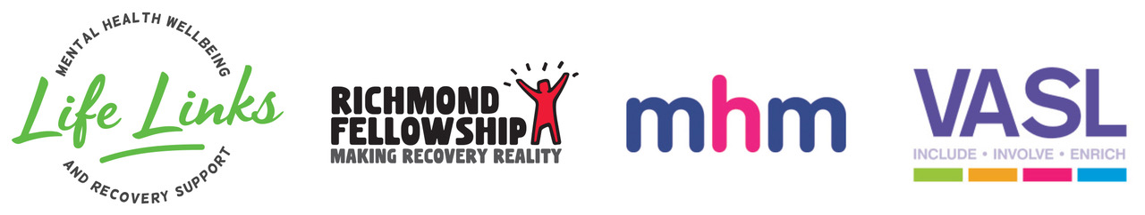

**Mental Health Wellbeing and Recovery Services Funded by:**

